DOCUMENT 07 — Frontend & Mobile Application Architecture
Visionary Internal · v1.0 · The 4-app shell (React Native + Web)

One shell, four permanent apps (Learn · Ask · Practice · Build), five role adapters.
The frontend never owns pedagogy; it renders what AIRA returns and captures every
interaction as an L7 event. Rule R6: no 5th app without founder sign-off.

1. Shell & navigation
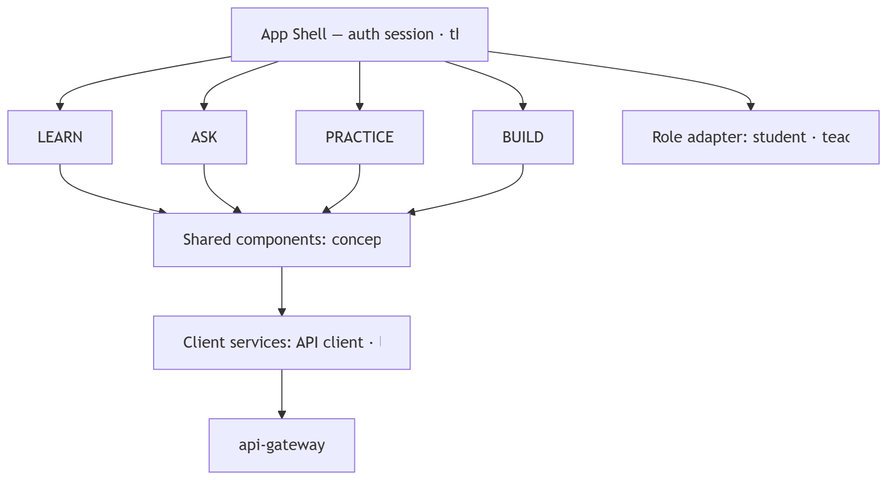
- Bottom tab bar = the 4 apps (permanent). Top bar = language badge (Ecoh · हिन्दी, Fix 04), AGI orb, account.
- Role adapter swaps content and intent, never the shell. Teacher/Parent/Org see the same 4 tabs with role-scoped data and permissions.

2. Screen inventory (per app)

App | Screens | Key components
Home (shell) | Today's path · Things I remember · Needs attention · Exam readiness · Take a break | decision-Home card, memory card, countdown
LEARN | Subject tabs → Chapter list → Concept lesson → 3D scene | chapter card (status/time/3D badge/bookmark), per-chapter Ask, comprehension check
ASK | Conversation · context chip · Socratic thread | chip 5 subjects · 32 topics, composer Ask me anything, Ecoh… (Fix 01), voice (Hindi ASR)
PRACTICE | Quiz setup → adaptive question → result → re-teach | 10-q/~20-min adaptive quiz, Re-practice vs Start, difficulty Foundational/Advanced/Mastered
BUILD | Project picker → canvas → portfolio → share | mastered 14 concepts → 3 projects, locked Master Motion first, shareable portfolio

3. State, offline, performance
- State: server-state via query cache (SCM, syllabus); client-state for drafts/canvas; session persisted locally so resume is exact (stage, language, notes).
- Offline: started lessons + downloaded Draco glTF assets playable offline; queued interactions flush to L7 on reconnect; "Saved on this device" only for acknowledged local persistence — no cloud-sync claim.
- Perf budget: TTI ≤2.5s on 4G; 3D 30fps on ₹8k Android (LOD + 2D SVG fallback); bundle split per app; fonts subset per script; Indic line-height ≥1.6, no overflow at 360px.

4. Accessibility & honesty rules
- WCAG 2.1 AA; 44px targets; mastery ring always numeric (never color-alone); never show bare 0 to a new user (Fix 02: "New topic — let's discover your level"); reduced-motion removes non-essential animation without hiding state.

OKF
KF1 app-switch <200ms · KF2 exact resume after kill/reopen · KF3 30fps 3D on Redmi-class · KF4 100% of interactions emit L7 event · KF5 full Indic rendering, zero overflow at 360px · KF6 role adapter leaks no cross-role data in UI.

